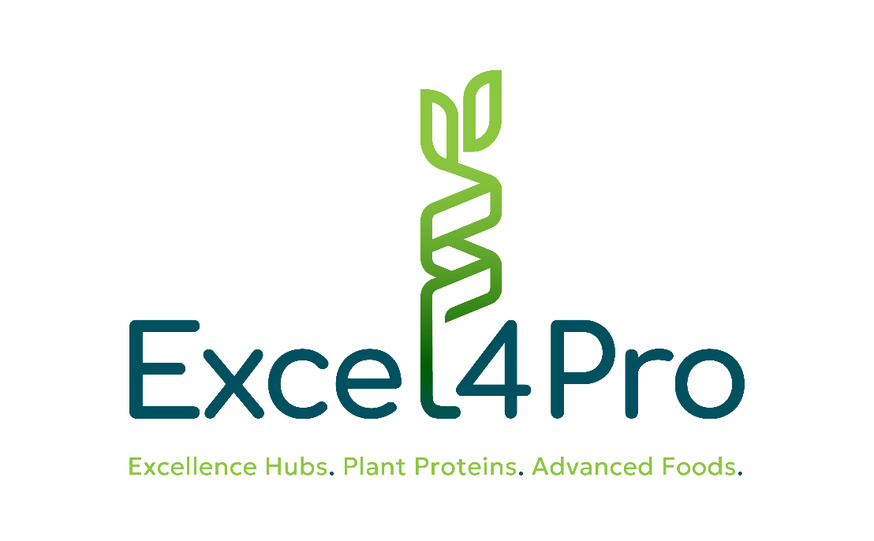


Strengthening the Capacity of Excellence Hubs of Türkiye, Greece, and Ukraine to Support Innovation Ecosystem of Novel Foods Based on Plant Proteins

Open Call for Financial Support to Third Parties to support innovation in the agri-food sector by focusing on novel foods based on plant proteins.

Annex 9: Frequently Asked Questions


LEGAL NOTICE
Funded by the European Union. Views and opinions expressed are however those of the author(s) only and do not necessarily reflect those of the European Union or European Research Executive Agency (REA). Neither the European Union nor the granting authority can be held responsible for them.

© Excel4Pro Consortium, 2025
Reproduction is authorised provided the source is acknowledged.

1. Where can I find more details on the Open Call? Any Guide for Applicants?
You can find more details on the Excel4Pro website (https://excel4pro.eu/), the European Commission's Funding and Tenders portal, and the opencalls.fund platform. The primary document containing all the rules and guidelines is the Applicants Guide (Annex 4), which is part of the Open Call Kit.

2. Are single applicants eligible to apply?
The call is specifically designed for single applicants. An eligible applicant must be a single legal entity—specifically a start-up or an SME. You do not need to form a consortium to apply.

3. How many applications can one entity submit? And how many of them can be selected for funding?
If an applicant is found to be participating in multiple applications with different scopes, all of their project applications will be rejected. If multiple versions of the same application are submitted, only the final version will be evaluated. Since you can only submit one proposal, a maximum of one can be selected for funding. Across the entire Open Call, a total of 9 sub-projects will be selected (3 from each of the participating countries).

4. For how long will the platform accept proposals?
The platform opened for submissions on January 26th, 2026, and will accept proposals until April 27th, 2026, at 17:00 CET (Brussels time).

5. Can successful applicants receive payment in advance after contracting?
No, there is no advance payment. The guide explicitly states that no pre-financing is foreseen. The funding is distributed as a lump sum tied to specific milestones, meaning payments are strictly deliverable-based. You will only receive payments after successfully completing each of the three project phases and submitting the required deliverables (Activity plan, Report on Results, and Final report).

6. Can companies based outside the three Excel4Pro ecosystem countries submit an application?
No. To pass the overall eligibility criteria, the applying legal entity must be established in Türkiye, Greece, or Ukraine, and must also be eligible to participate in Horizon Europe. Businesses established outside these three specific countries are not eligible for this call.
Interested applicants after they register to the opencalls.fund platform can submit their additional questions to the designated tab FAQ. Within 48 hours, an answer will be published.



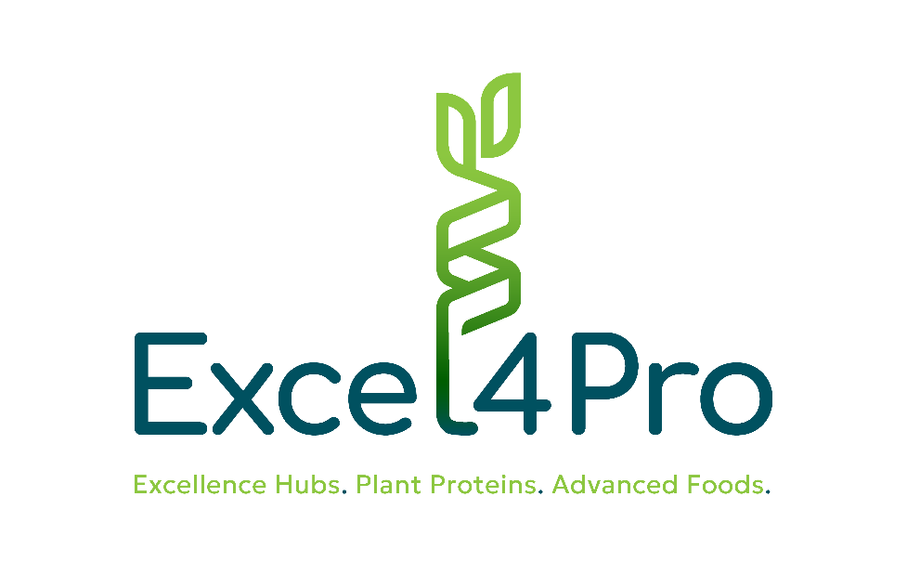




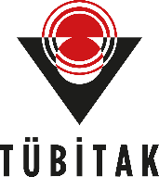




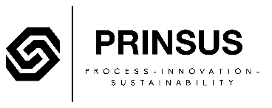

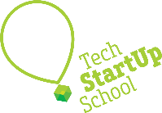

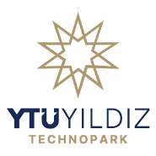
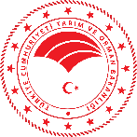
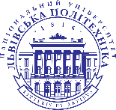

  - Our partners

